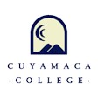

Cuyamaca College Health and Wellness

Respiratory Virus Guidance

Fall 2024

Self-Screening:

Student: Should self-screen daily for any respiratory virus. Symptoms include, but are not limited to fever, chills, cough, shortness of breath, fatigue, muscle or body aches, headache, new loss of taste or sell, sore throat, congestion, runny nose, nausea, vomiting or diarrhea.

Testing Positive for Covid 19 Respiratory Virus: Student may contact Health and Wellness Nursing Services to seek guidance for the Covid 19 Respiratory Virus at: [Cuyamaca.wellness@gcccd.edu](mailto:Cuyamaca.wellness@gcccd.edu) or by calling 619-660-4200

For Other Respiratory Viruses: Please contact your Primary Care Provider.

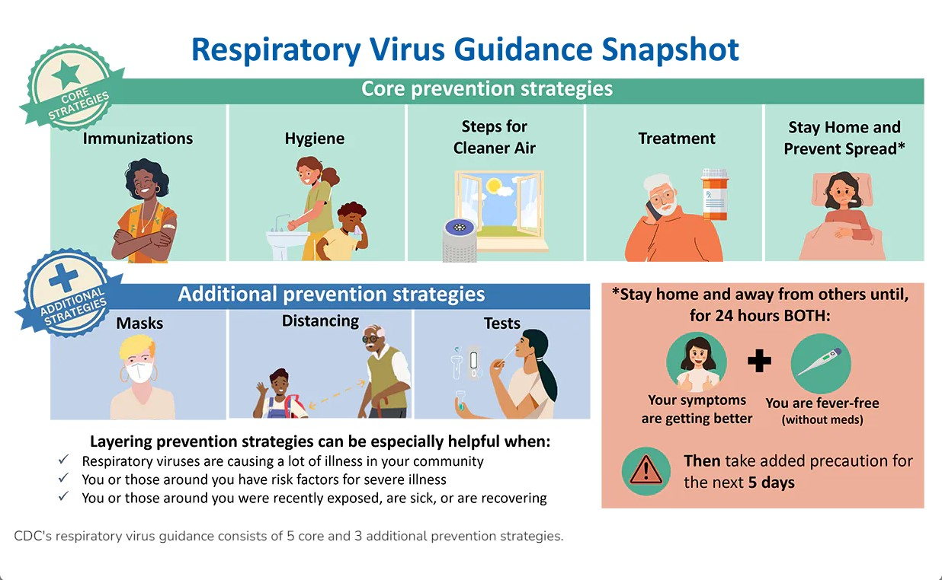

Helpful Resource Link:

<https://www.sandiegocounty.gov/content/sdc/hhsa/programs/phs/community_epidemiology/dc/respiratoryviruses/RVCaseGuide.html#if-sick>

Health and Wellness Services 619-660-4200