**Cardiovascular Technology Program**

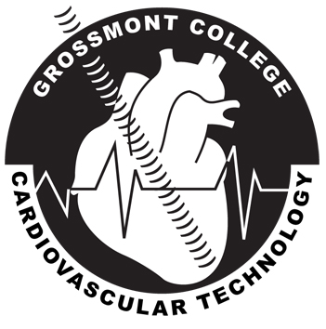

**Region X Community Colleges**

**2022-2024**

**THIS PREREQUISITE GRID IS DESIGNED TO BE USED AS AN ADVISING TOOL, ONLY, AND NOT A GUARANTEE OF COURSE EQUIVALENCY FOR PRIOR COURSE WORK.**

**\*SDCCD includes: San Diego City College, San Diego Mesa College, and MiraMar College.**

|  |  |  |  |  |  |  |  |  |
| --- | --- | --- | --- | --- | --- | --- | --- | --- |
| **GROSSMONT** | **CUYAMACA** | **SOUTHWESTERN** | **SDCCD** | **MIRACOSTA** | **PALOMAR** | **IVC** | **SDSU** | **CSUSM** |
| BIO 140 &  BIO 141, 141L or  BIO 144 & 145 | BIO 140 &  BIO 141, 141L | BIOL 260 & BIOL 261 | BIOL 230 & BIOL 235 | BIO 210 & BIO 220 | BIO 210 & BIO 211 | BIO 204 & BIO 206  BIO 200 & 202 | BIOL 212, BIO 261, BIO 211/+L | BIOL 175, BIOL 176, BIOL 160 |
| CHEM 115 or equivalent | CHEM 115 or equivalent | CHEM 100 | CHEM 100 & 100L or  CHEM 152 & 152L or  CHEM 103 (Miramar only) | CHEM 115 or 115H | CHEM 100 | CHEM 100 | CHEM 100 | CHEM 105, CHEM 105L |
| **Degree Requirements** | | | | | | |  |  |
| ENGL 120 or  ENGL 124 or  ESL 122 | ENGL 120 or  ENGL 124 or  ESL 122 | ENGL 115, 115H or  ENGL 116 or  ADN 140 or  ESL 115A | ENG 101 or  ENG 105 or  ENG 205  Note: ENGL 105 N/E to CSUSM LTWR 115 | ENGL 100 or 100H or  ENGL 201 or 201H or  ENGL 202 or 202H or | ENG 100 or  ENG 202 or  ENG 203 or  ESL 110 | ENG 110 or  ENG 105 or  ENG 201 | RWS 100 or  LING 100B  RWS 200 | GEW 101 or LTWR 115 |
| COMM 120 or  COMM 122 | COMM 120 or  COMM 122 | COMM 174 or  COMM 103 or  COMM 104 | COMS 135 & COMS103 | COMM 101 | SPCH 115 or  SPCH 100 | COMM 100 | COMS 245 or COMM 103 | GEO 102 or any CSU A1 course |

**Notes**

The Cardiovascular Technology program does not accept 1-semester Anatomy and Physiology (e.g. SWC BIO 190) courses designed for other specialized health programs. Students are encouraged to meet with a Counselor to review program prerequisites and degree requirements. Current students can schedule an appointment by visiting the Counseling “[Online Appointment System](http://web4.gcccd.edu/gcsars/GC-Center/eSARS.asp?WCI=Init&WCE=Settings)”. Alternatively, current students can get quick questions answered by using the “[Email a Counselor](https://www.grossmont.edu/student-support/counseling/online-counseling.php)” service.

Students should visit the [Cardiovascular Technology website](https://www.grossmont.edu/academics/programs/cvt/index.php) to review FAQs regarding admission to the program.

***Every effort has been made to ensure this information is accurate. However, the official college document is the Grossmont College Catalog for years 22-24.